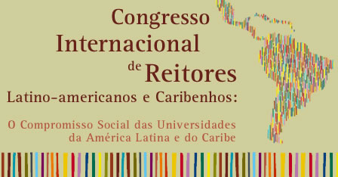


Latin American and Caribbean Universities Social Responsibility Exhibition

Data for deposit in Banco do Brasil account at New York

(only for foreign institutions)

Banco do Brasil - 001

Agency: 06866

Account: 84.277.011.7

Routing number: 026.003.557

Obs. To confirm your registration, it is necessary that you send the voucher of the deposit for fax +55 31 34994549, for Ms. Clara. Please, inform the number of the voucher, the name of the event and the full name of the participant and institution.

