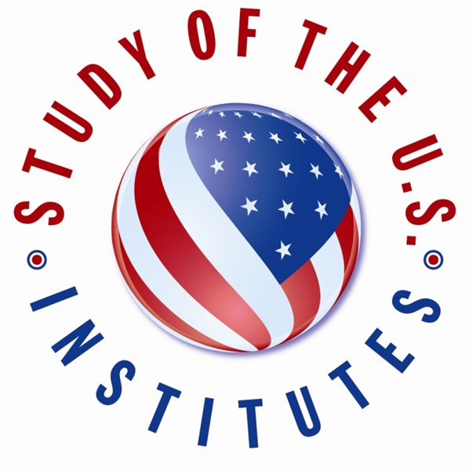

INSTRUCTIONS:
- Please submit the below form to your professor or selection committee in the deadline set by your institution.
- Applications sent directly to the Embassy Branch Office in Belo Horizonte will not be consider.
- Please save this form with the Higher Education Institution’s name, candidate’s name and surname. Examples: UCR_John Smith, UFLA_Joao Silva.
- In case you are sending images please save them on PDF format with your name, surname and name of the University. Examples: Joao Silva_Transcript, Maria Santos_TOEFL.
- Send all information together in a single e-mail message. Only electronic, scanned (PDFs) documents will be accepted.
- Type N/A for questions that are non-applicable
- Please delete the instruction information when saving the file with your data.

----------------------------------------------------------------------------------------------------------------------------------------

Application Form: Winter 2023 Study of the
U.S. Institute for Student Leaders on Entrepreneurship and economic development

SECTION A: candidate information

- Applicant's full name: (exactly as they appear in passport or national identity document)
Surname:
Middle name:
First name:
Gender:
☐ Female
☐ Male
☐ Other: _______________

Date of Birth: (month/day/year - please spell the month, e.g.: February 15, 1986)

City and State of Birth:
Country of Birth:
Country of Residence
Primary Citizenship:
Secondary Citizenship (if applicable):

- Contact information: (please write the name of the street in Portuguese)
Address:
City: State:
Postal Code: Country:
Phone number (country code + DDD):
Cell Phone (country code + DDD):
E-mail:

- Medical, Physical, Dietary or other Personal Considerations: This will not affect selection but will enable the host institution to make any necessary accommodations.
Please indicate if the candidate has a disability:
☐ None
☐ Blind or Visual Impairments
☐ Deaf or Hearing Impairments
☐ Learning Disability
☐ Physical Disability
☐ Psychiatric Disability
☐ Systemic Disability
☐ Other: ___________________

- Please describe any pre-existing medical conditions, prescription medication, dietary restrictions, or personal considerations for the candidate.

- Previous Experience in the United States. Please list all trips to the United States and provide dates/duration, purpose of visit(s), and location(s)). (Examples: July 4-14, 2019 - Tourism to Washington, D.C.; December 1-15, 2018 - Short Term Study Abroad to NYC).

- Family residing in the United States (if applicable). Please list any immediate family members who are currently residing in the United States. Include name, relationship to candidate, city, and state. (Example: Jane Doe, sister, Denver, CO).

SECTION B: Background

- Academic Course, Institutions:
Course:
Higher Education Institution:
Department:
Year/semester in school:
Expected year/semester of graduation date:

- Work history. Please include employer, position, dates, and location.

- Volunteer Experience. Please include organization, dates, and location.

- Memberships in Associations, Clubs, etc. Please include organization, dates, and location.

- Candidate Personal Statement: As part of the SUSI application process, candidates should submit a personal statement about their background and goals. In up to 500 words, the candidate should address the following questions and any other pertinent information:
- What about your background and/or interests makes you competitive for the SUSI exchange program?
- What will you contribute to the program?
- How do you expect your participation in the SUSI exchange program affect your local community or, region/country?
- How will the SUSI exchange affect you personally or professionally?

- SECTION C: Documents

Please attach:
- Your most recent University Transcript or academic records (in Portuguese)
- Evidence of Fluency in English (TOEFL, TELP or other certificates, if available)
- Reference letter from a professor, supervisor, or employer

